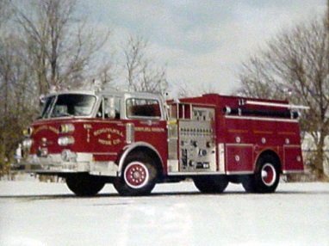

Cost $25.00
The Station
Annihilation
Food
Challenge
- 3 Patty Meat Wagon Burger!
- ½ Pound of Shoestring Fries w/Cheese Sauce!
- 22oz Milk Shake/ Vanilla or Chocolate!
- Complete in 30 mins to Win!
If you finish... I pay for the meal, I’ll give you a T-shirt, and your picture on the board.
“Hold it down for 15 minutes to complete”
5% Goes to L.F.D. Donation.

